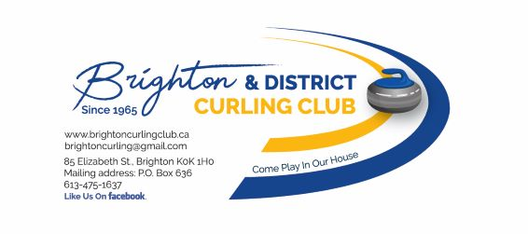 | Season Signup – Sep 16 to Sep 30 2023  Season First Half – Oct 15 2023 to Jan 19 2024  Season Second Half – Jan 21 2024 to Apr 12 2024
2023/2024 Season – Membership, League, and Optional Fees
Type of Fee | Description | Entry Type | Full Year | Half Year
Membership Dues | Annual Membership Dues (Mandatory For Adults 18yrs & Up)  Only paid once per Year | N/A | $35.00 | N/A
Capital New Facility Fund | Annual Capital Fee  (Mandatory For Adults 18yrs & Up)  Only paid once per Year | N/A | $ 10.00 | N/A
Associate Member | Non-curlers who wish to serve the Club in an advisory capacity & do not pay league fees. | N/A | $35.00 | N/A
Standard League Fee | Applicable to most of our 14 day-time and evening leagues | Individual/Team | $ 242.00 | $ 121.00
Mon Evening (First ½) | Adult Learn to Curl  (Dates TBD) | Individual | N/A | $ 58.00
Mon Evening (Second ½) | Rookie League  (Dates TBD) | Individual | N/A | $ 37.00
Fri. Evening Social | Open | Individual/Team | $ 110.00 | $ 55.00
Sunday Afternoon | Juniors Programme Ages 8 -17 | N/A | $ 80.00 | $ 40.00
2-Leagues Fees Cap | Reduced price for 2 standard-price leagues |  | $ 430.00 | $ 215.00
3 or more Leagues Fees Cap | Reduced price for unlimited curling |  | $ 514.00 | $ 257.00
Friday Night Social + 1 standard price league Cap | Reduced price for Friday Night Social + 1 standard price league |  | $ 352.00 | $ 176.00
Student | Full Time Attending College or University Under 18yrs.  (Unlimited Leagues) | N/A | $ 126.00 | $ 63.00
**Student | Full Time Attending College or University.  18yrs & Above  (Unlimited Leagues) | N/A | $ 126.00 | $ 63.00
Junior/Youth | Full Time in Elementary or Secondary School (in Adult Leagues) | N/A | $ 126.00 | $ 63.00
Casual Curling | Pay as you Play / Per Game  (Must be a Member) | N/A | $ 20.00 per  game | $ 20.00 per  game
Weekly 50/50 Draw | Full Year only. (No weekly or half year options.) | N/A | $ 48.00 | N/A
Locker(s) | 1st Come, 1st Served | N/A | $ 30.00 | N/A
Volunteer Opt Out | Paid once per Year | N/A | $ 40.00 | N/A

